Wiring and Construction
Refer to Figures 1 to 8 on our GitHub throughout this process
Light Sensing Unit:
- Take a breadboard, with a positive and a negative power rail.
- Set up the potential divider network using the 22k Ω, 10k Ω and 1k Ω resistors (as seen in Figure 1), and connect the output to the non-inverting input of the amplifier (OPA320).
- Connect together the cathodes and anodes of the 2 photodiodes. Connect the cathodes to the inverting input and the anodes to the 0V power rail. (Figure 1)
- Use 2 potentiometers of values 1M Ω and 500k Ω. Connect ‘Leg 1’ of the 1M Ω potentiometer to the amplifier output pin (Figures 1, 2), and ‘Leg 1’ of the 500k Ω potentiometer to ‘Leg 2’ of the 1M Ω potentiometer, and ‘Leg 2’ of the 500k Ω potentiometer to the inverting input of the amplifier (Figures 1, 2 and 3).
- Connect the positive supply pin of the amplifier to the positive power rail, and the negative supply pin to the 0V power rail.
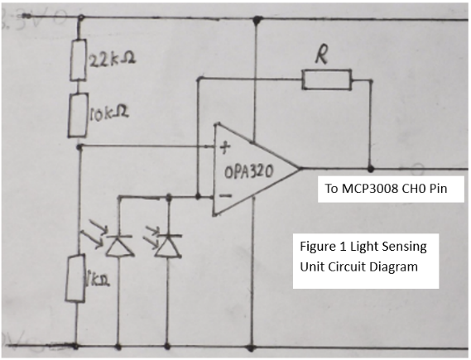
- Connect the output pin of the amplifier to CH0 of the MCP 3008 (Figure 3, 6).
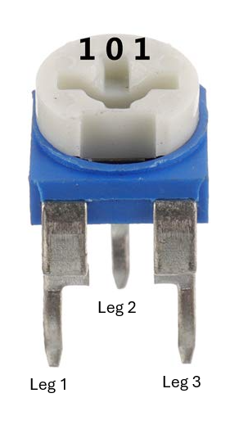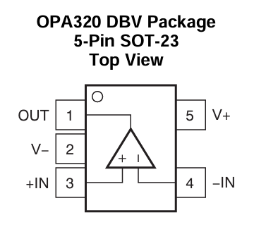
Figure 1
Figure 3
Figure 2
Figure 2
ADC Unit:
Connect, referring to Figures 4, 5 and 6:
- MCP3008 VDD to Positive Power Rail.
- MCP3008 VREF to Positive Power Rail.
- MCP3008 AGND to 0V Power Rail.
- MCP3008 DGND to 0V Power Rail.
- MCP3008 CLK to Raspberry Pi SCLK.
- MCP3008 DOUT to Raspberry Pi MISO.
- MCP3008 DIN to Raspberry Pi MOSI.
- MCP3008 CS/SHDN to Raspberry Pi CE0.
- Connect Raspberry Pi 3.3V Output Pin to Positive Power Rail.
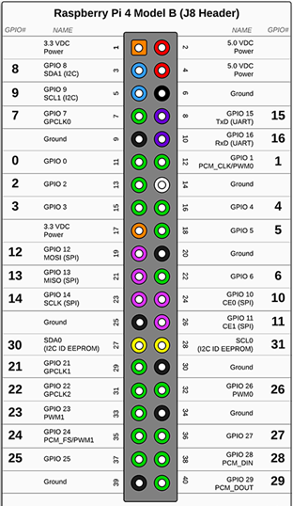
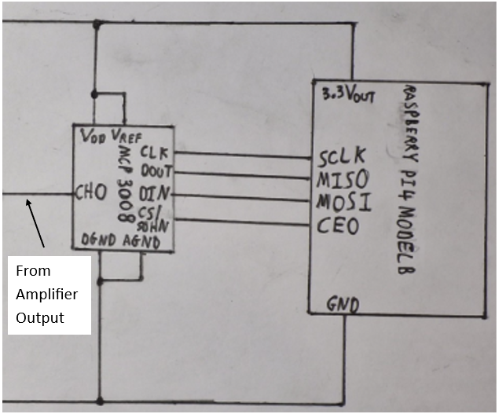

Figure 6
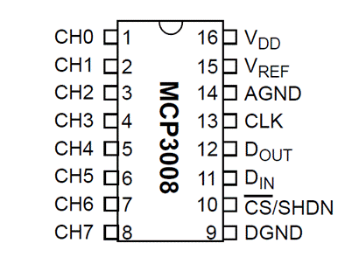

Figure 4

Output Light Unit:
Figure 5
- Connect the PWM Output Pin of the Pi to the Gate of the MOSFET (Figures 7, 8).
- Arrange 4 x 56 Ω resistors in parallel, with both ends of all the resistors joined together. Connect one end of the network to the drain of the transistor and the other end of the network to the negative end of the spotlight (Figure 7, 8).
- Connect the positive end of the spotlight the positive power rail of the 12V supply. (Figure 7).
- Connect the 0V power rail of the 12V supply to the source of the transistor, as well as to the GND, or Ground, Pin of the Raspberry Pi. (Figures 4, 7).
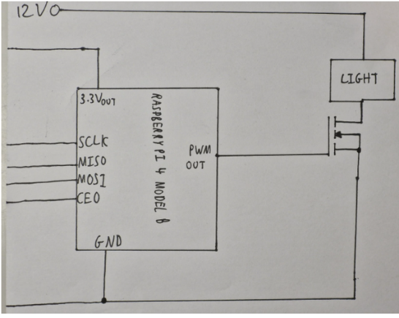
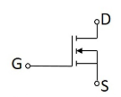

Figure 8
Figure 7
Software
- Install the following libraries onto the Raspberry Pi:
- Adafruit_MCP3008
- Customtkinter
- Matplotlib
- Pandas
- Run LDT Code.py program parallel to Light App.py
- If lamp is not responding accurately to the environment:
- Calibrate sensitivity by changing the values in the selection ranges.
- Calibrate the output by changing the return values.

